**Roll No. 16010421063**

**Batch No. G3**

**Name: Arya Nair**

**Experiment 2: Acid-Base titration:**

**Aim: To determine the unknown concentration of given acids using titrimetric method.**

The chemical reaction involved in acid-base titration is known as neutralization reaction. It involves the combination of H3O+ ions with OH- ions to form water. In acid-base titrations, solutions of alkali are titrated against standard acid solutions. The estimation of an alkali solution using a standard acid solution is called *acidimetry*. Similarly, the estimation of an acid solution using a standard alkali solution is called *alkalimetry*.

**The Theory of Acid–Base Indicators:**

Ostwald, developed a theory of acid base indicators which gives an explanation for the colour change with change in pH. According to this theory, a hydrogen ion indicator is a weak organic acid or base. The undissociated molecule will have one colour and the ion formed by its dissociation will have a different colour.

Let the indicator be a weak organic acid of formulae HIn. It has dissociated into H+ and In-. The unionized molecule has one colour, say colour (1), while the ion, In- has a different colour, say colour (2). Since HIn and In-have different colours, the actual colour of the indicator will dependent upon the hydrogen ion concentration [H+]. When the solution is acidic, that is the H+ ions present in excess, the indicator will show predominantly colour (1). On other hand, when the solution is alkaline, that is, when OH- ions present in excess, the H+ ions furnished by the indicator will be taken out to form undissociated water. Therefore, there will be larger concentration of the ions, In-. thus, the indicator will show predominantly colour (2).

Some indicators can be used to determine pH because of their colour changes somewhere along the change in pH range. Some common indicators and their respective colour changes are given below.

|  |  |  |  |
| --- | --- | --- | --- |
| **Indicator** | **Colour on Acidic Side** | **Range of Colour Change** | **Colour on Basic Side** |
| **Methyl Orange** | Red | **3.1 - 4.4** | Yellow |
| **Methyl Red** | Red | **4.4 - 6.2** | Yellow |
| **Phenolphthalein** | Colourless | **8.3 - 10.0** | Pink |

i.e., at pH value below 5, litmus is red; above 8 it is blue. Between these values, it is a mixture of two colours.

**Indicators Used for Various Titrations:**

**1. Strong Acid against a Strong Base:**

Let us consider the titration of HCl and NaOH. The pH values of different stages of titration shows that, at first the pH changes very slowly and rise to only about 4. Further addition of such a small amount as 0.01 mL of the alkali raises the pH value by about 3 units to pH 7. Now the acid is completely neutralized. Further of about 0.01 mL of 0.1 M NaOH will amount to adding hydrogen ions and the pH value will jump to about 9. Thus, near the end point, there is a rapid increase of pH from about 4 to 9.

An indicator is suitable only if it undergoes a change of colour at the pH near the end point. Thus the indicators like ***methyl orange, methyl red and phenolphthalein*** can show the colour change in the ph range of 4 to 10. Thus, in strong acid- strong base titrations, any one of the above indicators can be used.

**2. Weak Acid against Strong Base:**

Let us consider the titration of acetic acid against NaOH. The titration shows the end point lies between pH 8 and 10. This is due to the hydrolysis of sodium acetate formed. Hence ***phenolphthalein*** is a suitable indicator as its pH range is 8-9.8. However, methyl orange is not suitable as its pH range is 3.1 to 4.5.

**3. Strong Acid against Weak Base:**

Let us consider the titration ammonium hydroxide against HCl. Due to the hydrolysis of the salt, NH4Cl, formed during the reaction, the pH lies in the acid range. Thus, the pH at end point lies in the range of 4 to 6. Thus ***methyl orange*** is a suitable indicator while phenolphthalein is not suitable.

| **Strong Acids** | **Strong Bases** | **Weak Acids** | **Weak Bases** |
| --- | --- | --- | --- |
| HCl | NaOH | Acetic acid | Ammonia |
| HNO3 | KOH | Hydrocyanic acid | Magnesium hydroxide |
| HBr | Etc. | HF | Pyridine |
| H2SO4 |  | Oxalic acid | Sodium carbonate |
| HI |  | Ethanoic acid | Potassium carbonate |
| HClO4 |  | Etc. | Etc. |

**Procedure:**

* Choose the titrant.
* Choose the titrate.
* Select the normality of the titrate.
* Choose the volume of the liquid to be pipetted out.
* Select the indicator.
* Start titration.
* End point is noted at the colour change of the solution.
* From the final reading the normality of titrant can be calculated by the equation:

​

**Points to Remember while Performing the Experiment in a Real Laboratory:**

1. Always wear lab coat and gloves when you are in the lab. When you enter the lab, switch on the exhaust fan and make sure that all the chemicals and reagents required for the experiment are available. If they are not available, prepare the reagents using the components for reagent preparation.
2. Properly adjust the flame of the Bunsen burner. The proper flame is a small blue cone; it is not a large plume, nor is it orange.
3. Make sure to clean all your working apparatus with chromic acid and distilled water and ensure that all the apparatus are free from water droplets while performing the experiment.
4. Make sure to calibrate the electronic weigh balance before taking the measurements.
5. Clean all glassware with soap and distilled water. Once the experiment is completed, recap the reagent bottles. Switch off the light, exhaust fan and gas cylinder before leaving the lab.
6. Discard used gloves in a waste bin.

**Observations:**

|  |  |  |  |  |  |
| --- | --- | --- | --- | --- | --- |
| **No.** | **Acid** | **Base** | **Indicator** | **Volume (mL)** | **Remark** |
| 1 | HCl | NaOH | Methyl Orange | 2 | It turns brown |
| 2 | H2SO4 | NaOH | Methyl Orange | 2 | It turns brown |
| 3 | Hydrobromic acid | NaOH | Methyl Orange | 2 | It turns brown |
| 4 | Oxalic acid | NaOH | Methyl Orange | - | Invalid Indicator |
| 5 | Acetic acid | NaOH | Methyl Orange | - | Invalid Indicator |
| 6 | HCl | NaOH | Phenolphthalein | 2 | It becomes colourless |
| 7 | H2SO4 | NaOH | Phenolphthalein | 2 | It becomes colourless |
| 8 | Hydrobromic acid | NaOH | Phenolphthalein | 2 | It becomes colourless |
| 9 | Oxalic acid | NaOH | Phenolphthalein | 2 | It becomes colorless |
| 10 | Acetic acid | NaOH | Phenolphthalein | 2 | It becomes colourless |
| 11 | HCl | NaOH | Methyl Red | 2 | It turns maroon red |
| 12 | H2SO4 | NaOH | Methyl Red | 2 | It turns maroon red |
| 13 | Hydrobromic acid | NaOH | Methyl Red | 2 | It turns maroon red |
| 14 | Oxalic acid | NaOH | Methyl Red | - | Invalid Indicator |
| 15 | Acetic acid | NaOH | Methyl Red | - | Invalid Indicator |
| 16 | HCl | KOH | Methyl Orange | 2 | It turns brown |
| 17 | H2SO4 | KOH | Methyl Orange | 2 | It turns brown |
| 18 | Hydrobromic acid | KOH | Methyl Orange | 2 | It turns brown |
| 19 | Oxalic acid | KOH | Methyl Orange | - | Invalid Indicator |
| 20 | Acetic acid | KOH | Methyl Orange | - | Invalid Indicator |
| 21 | HCl | KOH | Phenolphthalein | 2 | It becomes colourless |
| 22 | H2SO4 | KOH | Phenolphthalein | 2 | It becomes colorless |
| 23 | Hydrobromic acid | KOH | Phenolphthalein | 2 | It becomes colorless |
| 24 | Oxalic acid | KOH | Phenolphthalein | 2 | It becomes colorless |
| 25 | Acetic acid | KOH | Phenolphthalein | 2 | It becomes colorless |
| 26 | HCl | KOH | Methyl Red | 2 | It turns maroon red |
| 27 | H2SO4 | KOH | Methyl Red | 2 | It turns maroon red |
| 28 | Hydrobromic acid | KOH | Methyl Red | 2 | It turns maroon red |
| 29 | Oxalic acid | KOH | Methyl Red | - | Invalid Indicator |
| 30 | Acetic acid | KOH | Methyl Red | - | Invalid Indicator |
| 31 | HCl | NH4OH | Methyl Orange | 2 | It turns brown |
| 32 | H2SO4 | NH4OH | Methyl Orange | 2 | It turns brown |
| 33 | Hydrobromic acid | NH4OH | Methyl Orange | 2 | It turns brown |
| 34 | Oxalic acid | NH4OH | Methyl Orange | - | Invalid Indicator |
| 35 | Acetic acid | NH4OH | Methyl Orange | - | Invalid Indicator |
| 36 | HCl | NH4OH | Phenolphthalein | - | Invalid Indicator |
| 37 | H2SO4 | NH4OH | Phenolphthalein | - | Invalid Indicator |
| 38 | Hydrobromic acid | NH4OH | Phenolphthalein | - | Invalid Indicator |
| 39 | Oxalic acid | NH4OH | Phenolphthalein | - | Invalid Indicator |
| 40 | Acetic acid | NH4OH | Phenolphthalein | - | Invalid Indicator |
| 41 | HCl | NH4OH | Methyl Red | 2 | It turns maroon red |
| 42 | H2SO4 | NH4OH | Methyl Red | 2 | It turns maroon red |
| 43 | Hydrobromic acid | NH4OH | Methyl Red | 2 | It turns maroon red |
| 44 | Oxalic acid | NH4OH | Methyl Red | - | Invalid Indicator |
| 45 | Acetic acid | NH4OH | Methyl Red | - | Invalid Indicator |
| 46 | HCl | Na2CO3 | Methyl Orange | 2 | It turns brown |
| 47 | H2SO4 | Na2CO3 | Methyl Orange | 2 | It turns brown |
| 48 | Hydrobromic acid | Na2CO3 | Methyl Orange | 2 | It turns brown |
| 49 | Oxalic acid | Na2CO3 | Methyl Orange | - | Invalid Indicator |
| 50 | Acetic acid | Na2CO3 | Methyl Orange | - | Invalid Indicator |
| 51 | HCl | Na2CO3 | Phenolphthalein | - | Invalid Indicator |
| 52 | H2SO4 | Na2CO3 | Phenolphthalein | - | Invalid Indicator |
| 53 | Hydrobromic acid | Na2CO3 | Phenolphthalein | - | Invalid Indicator |
| 54 | Oxalic acid | Na2CO3 | Phenolphthalein | - | Invalid Indicator |
| 55 | Acetic acid | Na2CO3 | Phenolphthalein | - | Invalid Indicator |
| 56 | HCl | Na2CO3 | Methyl Red | 2 | It turns maroon red |
| 57 | H2SO4 | Na2CO3 | Methyl Red | 2 | It turns maroon red |
| 58 | Hydrobromic acid | Na2CO3 | Methyl Red | 2 | It turns maroon red |
| 59 | Oxalic acid | Na2CO3 | Methyl Red | - | Invalid Indicator |
| 60 | Acetic acid | Na2CO3 | Methyl Red | - | Invalid Indicator |

**Screenshot output-**

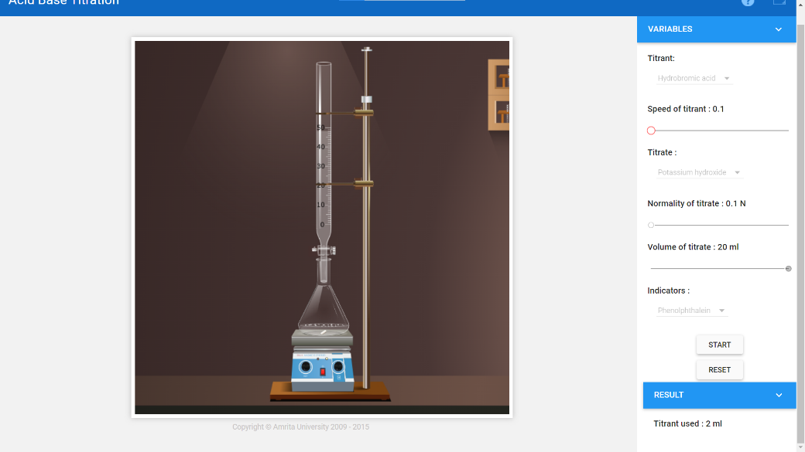

Titrant- Hydrobromic Acid

Titrate- Potassium Hydroxide

Indicator- Phenolphthalein

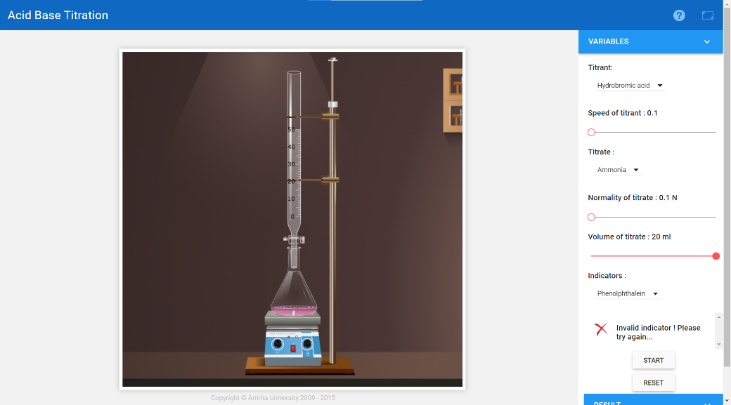

Titrant- Hydrobromic Acid

Titrate- Ammonia

Indicator- Phenolphthalein

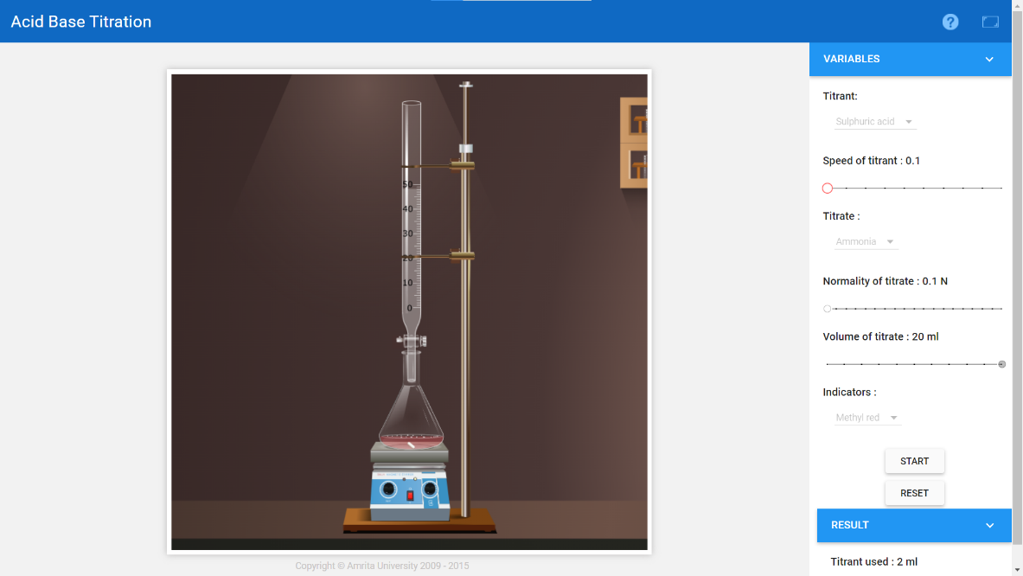

Titrant- Sulphuric Acid

Titrate- Ammonia

Indicator- Methyl Red



**Acid Vs Base**

**N1 * 2ml = 0.1 * 20 mL**

**N1 = 1N**

**Result:** Normality of the acid is = 1N